
Mad World
Gary Jules, 2001 (Key of Eb, Original)
CHORDS:
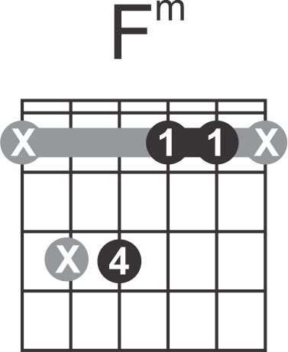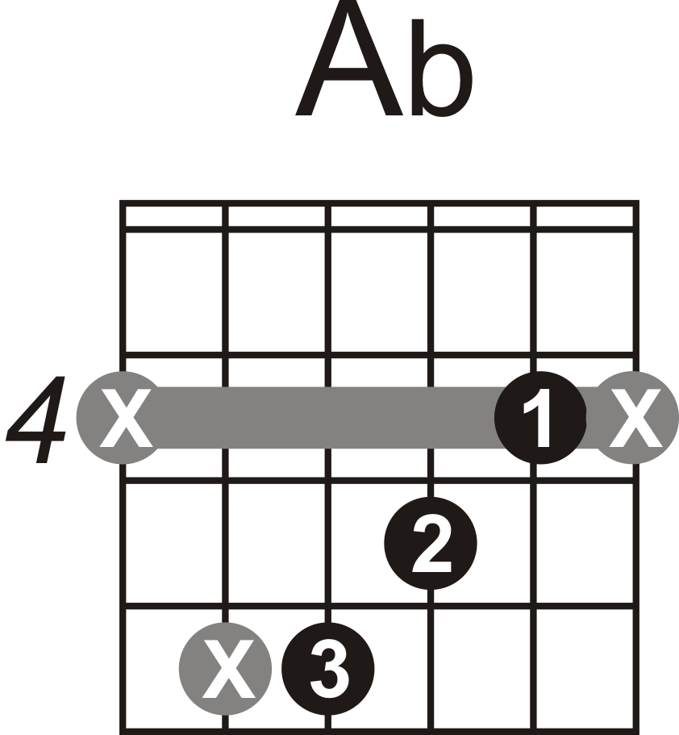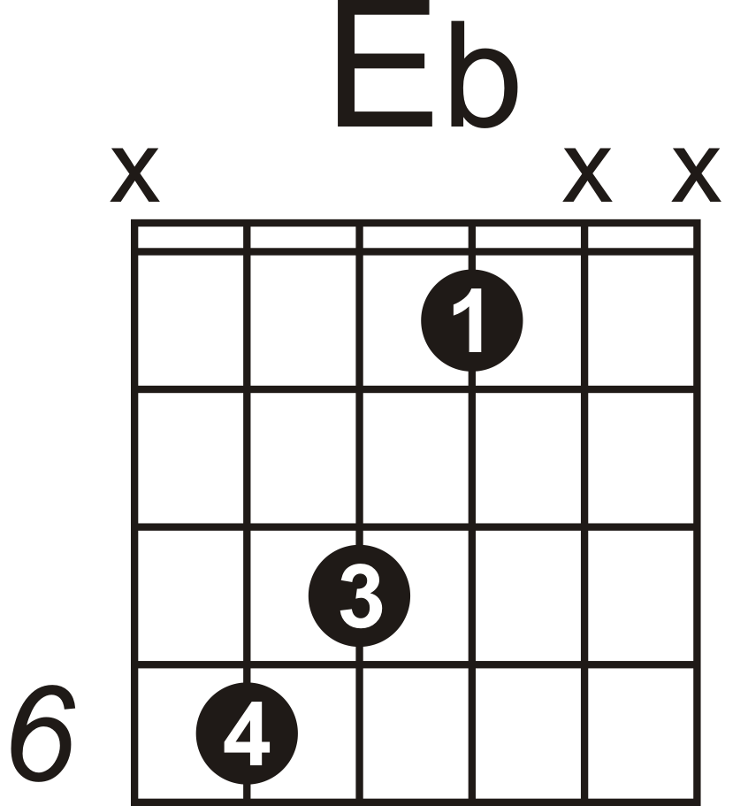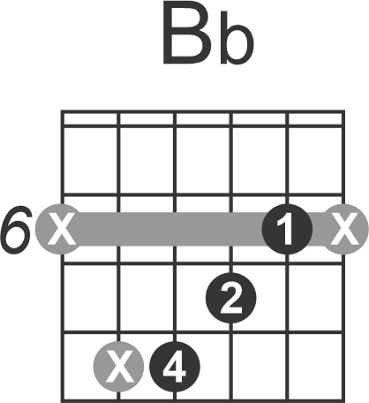
Alternate:
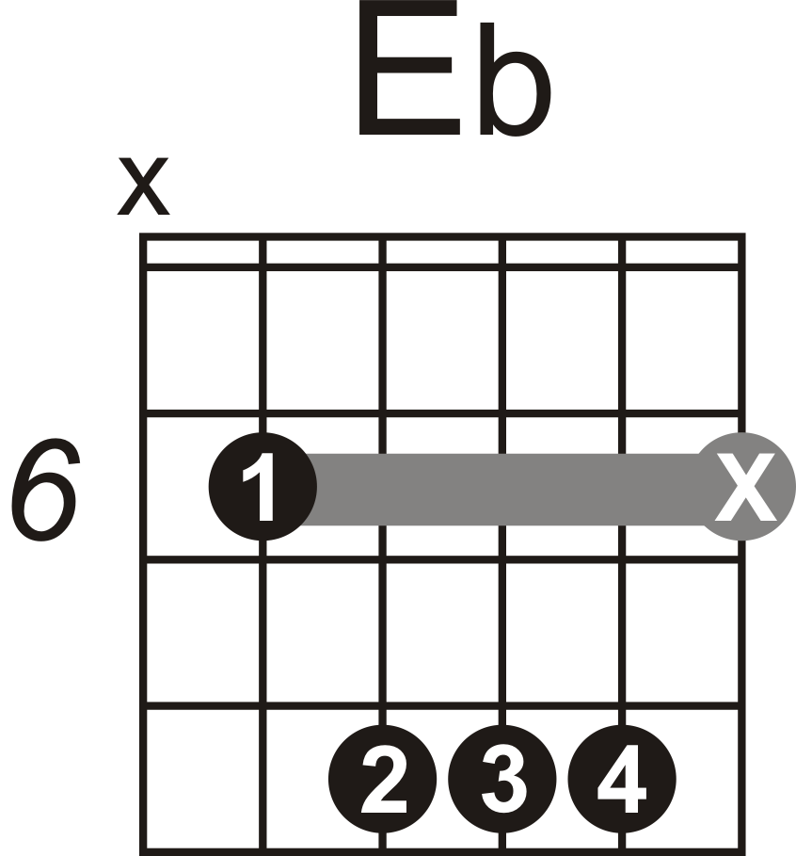
LEGEND:

*All chord changes occur at either the 1st or middle beat (i.e. 3rd beat in 4/4 time signature) when not shown.
**Gray colored chords mean do not play any Bass Guitar
***Lyrics sung by backup vocalists are indicated by italicized lyrics
[#] - “#” indicates at what beat a chord changes (optional)
- “&” indicates 8th note intervals
- “e”, “&”, “a” indicates 16th note intervals
- “te”, “ta” indicates triplet note intervals
{#.} - on repeats, “#” indicates which time to play (1st, 2nd,… time)
 - reference a similar riff/pattern
½T - Half Time
 - only
 - except
// - abrupt stop (when placed before a beat, end before that beat; if placed after a beat, end on that beat. When multiple beats are shown ^{(#,#)} more than one hit is required.)
// - stop and hold (When multiple beats are shown ^{(#,#)} more than one hit is required.)
: : - repeat passage between two colons
dstrn - distortion
Vamp - passage of music played as many times as needed

